Project Planning Phase
Project Planning Template (Product Backlog, Sprint Planning, Stories, Story points)
Date | 29 September 2026
Team ID | SWTID-2026-5228
Project Name | Import Data using Transform Maps (Spreadsheet)
Maximum Marks | 5 Marks
Product Backlog, Sprint Schedule, and Estimation (4 Marks)
Use the below template to create product backlog and sprint schedule
Sprint | Functional Requirement (Epic) | User Story Number | User Story / Task | Story Points | Priority | Team Members
Sprint-1 | Table & Data Setup | USN-1 | As a customer data administrator, I can create a custom customer table in ServiceNow. | 2 | High | Harini V
Sprint-1 | Table & Data Setup | USN-2 | As a customer data administrator, I can add the customer fields (Customer ID, Name, Email, City, Account Type) with the right types. | 2 | High | Harini V
Sprint-1 | Table & Data Setup | USN-3 | As a customer data administrator, I can prepare an Excel sheet with a header row that matches the table fields. | 3 | High | Harini V
Sprint-1 | Import Data | USN-4 | As a customer data administrator, I can upload the Excel file using System Import Sets > Load Data. | 1 | High | Harini V
Sprint-1 | Import Data | USN-5 | As a customer data administrator, I can open the staging table and check the loaded rows. | 1 | Medium | Harini V
Sprint-1 | Data Submission | USN-11 | As a sales or support team member, I can send the latest customer data in an Excel sheet to the administrator. | 1 | Medium | Harshini P
Sprint-2 | Transform & Mapping | USN-6 | As a customer data administrator, I can create a Transform Map from the Import Set table to the customer table. | 2 | High | Harshini S
Sprint-2 | Transform & Mapping | USN-7 | As a customer data administrator, I can map the source fields to the target fields using Auto Map Matching Fields and Mapping Assist. | 3 | High | Harshini S
Sprint-2 | Transform & Mapping | USN-8 | As a customer data administrator, I can run the transform and check the Transform History. | 2 | High | Divya Shree S
Sprint-2 | Duplicate Prevention | USN-9 | As a customer data administrator, I can enable Coalesce on Customer ID so existing customers are updated instead of duplicated. | 5 | High | Harshini K
Sprint-3 | Validation | USN-10 | As a customer data administrator, I can validate the imported records in the customer table. | 3 | Medium | Divya Shree S
Sprint-3 | Reporting | USN-12 | As a customer support manager, I can view a pie chart of customers by account type. | 2 | Medium | Harshini S
Sprint-3 | Reporting | USN-13 | As a customer support manager, I can view a bar chart of customers by city. | 2 | Medium | Harshini S
Sprint-3 | Reporting | USN-14 | As a customer support manager, I can see the saved reports together on a dashboard. | 2 | Low | Harshini S
Sprint-3 | Security (Roles & ACL) | USN-15 | As a system administrator, I can create a role and assign it to a user. | 2 | Medium | Divya Shree S
Sprint-3 | Security (Roles & ACL) | USN-16 | As a system administrator, I can create ACLs that give read and write access to the customer table only to that role. | 3 | Medium | Divya Shree S
Project Tracker, Velocity & Burndown Chart: (4 Marks)
Sprint | Total Story Points | Duration | Sprint Start Date | Sprint End Date (Planned) | Story Points Completed (as on Planned End Date) | Sprint Release Date (Actual)
Sprint-1 | 10 | 6 Days | 29 Sep 2026 | 04 Oct 2026
Sprint-2 | 12 | 6 Days | 05 Oct 2026 | 10 Oct 2026
Sprint-3 | 14 | 6 Days | 12 Oct 2026 | 17 Oct 2026
Velocity:
Our sprint duration is 6 days, and the velocity of the team is 12 (story points per sprint). Let’s calculate the team’s average velocity (AV) per iteration unit (story points per day)
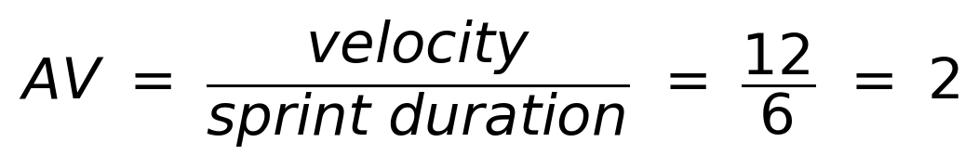
Burndown Chart:
A burn down chart is a graphical representation of work left to do versus time. It is often used in agile software development methodologies such as Scrum. However, burn down charts can be applied to any project containing measurable progress over time.
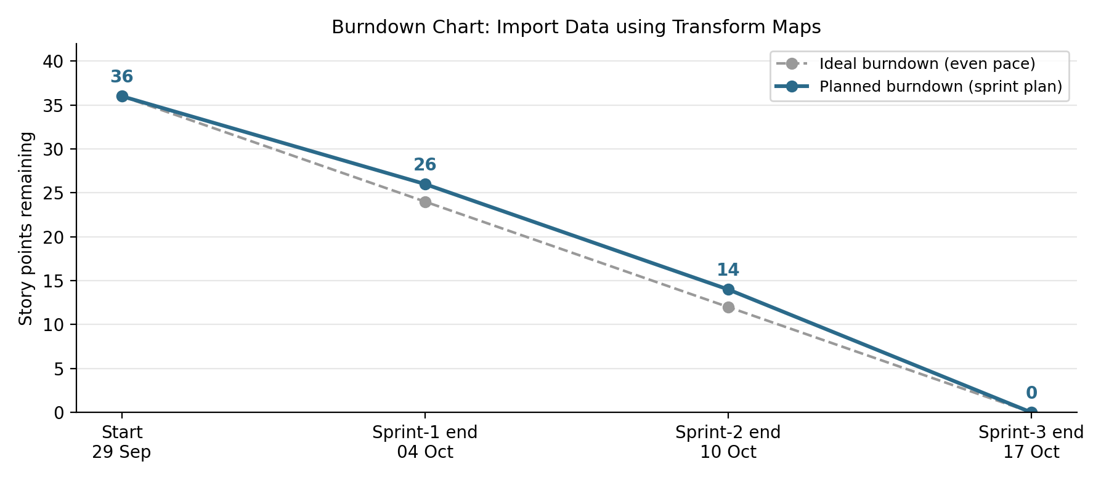
https://www.visual-paradigm.com/scrum/scrum-burndown-chart/
https://www.atlassian.com/agile/tutorials/burndown-charts
Reference:
https://www.atlassian.com/agile/project-management
https://www.atlassian.com/agile/tutorials/how-to-do-scrum-with-jira-software
https://www.atlassian.com/agile/tutorials/epics
https://www.atlassian.com/agile/tutorials/sprints
https://www.atlassian.com/agile/project-management/estimation
https://www.atlassian.com/agile/tutorials/burndown-charts

